**CHAPTER-1**

**Introduction of the project**

1

**Introduction of the project**

The title of these project is Search Result that is totally computerized based and offline works and handle all the activities of the searching an data/item from the database of any organization, university, hospital etc The search in the university likes related to the student, faculty and courses etc, search in the hospital like patient, doctor and medicines etc.

In the computer system the search may be files, folder, images, songs (audio, video), documents (word processing, spreadsheet etc).

It will be search only those item that have already exist in the database, if the search data will be found in the database then it will be show search item otherwise display the message “The item does not exist”.

2

**CHAPTER-2**

**ANALYSIS OF Proposed System and System requirements**

3

**2.1 System Analysis**

System analysis is the process of gathering and interpreting facts. Diagnosing problems, and using the information to recommend improvements to the system.

One of the main functions of system analyst is to convert an existing computerized system into computerized system. The system analyst does so by defining in broad outline how the problem in the outside world is top be related to a computer system. It is from this language that the programmers work.

There are two approaches for developing the system. There are:-

1. Top down approach
2. Bottom up approach

As far as analysis of the project is connected, I have followed a top down strategy for developing description of the system. An initial overview model is explored into more detailed, lower level diagrams that show additional features of the system. Each process has been broken down into a yet more detailed data flow diagram.

4

**2.1.1 Need for the System**

We goal to provide an application that can be used by an enterprise to improve productivity, facilitate communication among the employees and ensure better coordination inside the organization and The purpose of our software is to reduce the manual and paper work so as to minimize the consumption of time and efforts of employees leading to the proper management of the resources.

Presently the software is developed particularly as generic software and hence will be applicable to all the kinds of organizations but by making certain enhancements (like fixing the organization hierarchy, varying employee privileges as per requirement) in the software, it can be customized and hence can be used by specific organizations. Moreover the software can be used by any type of organizations.

This software ”Search Result” would really be beneficial for any enterprise as the complete management of the enterprise could be easily handled and fast access the information about any user, files and documents etc. by this and moreover it will also be affordable even for small organizations.

**2.1.2 Objectives of the Project**

The main objective of this project to reduce the time consumption which is

5

required for the manual system.

Other objectives is to keep the organization/company data secure to unauthorized persons and hand to hand process

The purpose of our software is to reduce the manual and paper work so as to minimize the consumption of time and efforts of employees leading to the proper management of the resources. Hence the efficiency of the organization will increase with the use of our software.

Along with the above mentioned fact there is one more important thing to be taken into consideration that the enterprise management software are generally costly for any small organization to afford as it is build on customized basis. Thereafter increasing the cost of the software .Thus here we are making generic software which could be used by any organization and would also be affordable.

We aim to provide an application that can be used by an enterprise to improve productivity, facilitate communication among the employees and ensure better coordination inside the organization.

**2.1.3 Process Model**

* The process model used for this project is “Waterfall Model”. The Waterfall model combines the elements of the linear sequential model with the iterative philosophy of prototyping.

6

* When a waterfall model is used, the first increases are often a core product. That is basic requirements are addressed, but many supplementary features remain undelivered. The core product is used by the customer as a result of use and evaluation a plan is developed for the next increment.

# Waterfall Model

# The waterfall model suggests systematic approaches to software development that begin at the system level and progresses through analysis, design, coding, testing and support. The principle stages of the model:-

# 

# 1. Requirement Definition – The system’s services, constraints a

# are established by consultation within system users. They are then defined in detail and serve as system specifications.

# 2. System and Software Design – The system design process partitions the requirements to either hardware or software systems. It establishes overall system architecture.

3. Implementation and Unit Testing – During this stage the software

design is relished as a set of programs or program units. Unit testing

involves verifying that each unit meets its specifications.

7

4.Integration and System Testing – The individual program units or program are integrated and tested as a complete system to ensure that the software requirements have been met.

5.Operation and Maintenance – Normally this is the longest life cycle phase. The system is installed and put into practical use. Maintenance involves correcting errors which were not discovered in earlier stages of the life cycle.

Advantages:-

**1**  Generates working software quickly and early during the software life cycle.

2 More flexible – less costly to change scope and requirements.

3 Easier to test and debug during a smaller iteration.

4 Easier to manage risk because risky pieces are identified and handled during its iteration.

5 Each iteration is an easily managed milestone.

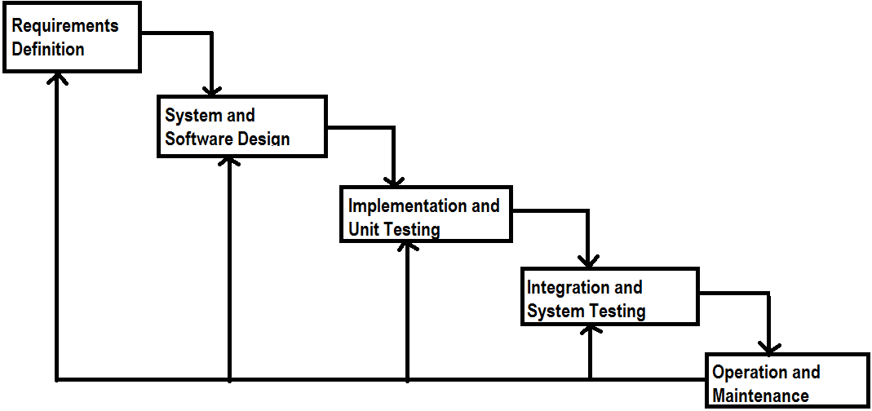

Fig: Waterfall Model

8

**2.1.4 Hardware and Software Requirements**

**For Development:**

**Hardware Requirements:-**

Processor: - Pentium® Dual-Core

RAM: - 2.00GB

Hard Disk: - 10 GB or Requirement of Data

System Type: - 32-bit Operating System

**Software Requirements:-**

Language/Technology: - Java (jdk1.6.0, J2SE )

Database: - SQL Server

Operating System: - Windows 7

Windows Ultimate

Product ID: 00426-OEM-8992662-00400

9

**2.1.5 Feasibility Study**

After the analysis of the requirement from the proposed system and specification of the proposed system, a feasibility study of the projected system is conducted. The feasibility study is done to find whether the system is beneficial to user and organization or not.

The feasibility study is carried out to select the best system that meets performance requirements. The feasibility study includes the investigation of the information needs of the end user and objectives, constraints, basic resource requirement and cost and benefits.   
 The aim of a feasibility study is to see whether it is possible to develop a system at a reasonable cost. At the end of the feasibility study a decision is taken whether to proceed or not.

**Economic Feasibility:**

Today, the software is the most expensive element of virtually all computer based system. Various variables like human, technical, environmental can affect ultimate cost of software the software is the most expensive element of virtually all computer and efforts applied to develop it. In our project as the platform required (JAVA platform) and SQL server is available in freeware form so cost estimation of project is very less.

**Technical Feasibility:**

The JAVA based technologies which we are using for the development of the project are already in wide use. Other than this we will use Jakarta Tomcat and SQL Server. All these software are also readily available & thus the development of project is technically feasible.

10

**Behavioral Feasibility:**

Working behavior of product is user friendly, anyone can operate easily, for this we will develop user interface with user friendliness. Further the screen design in the system will follow the constant patterns that will be approved by

**2.1.6 Project Cost & Time**

**Project Cost: - COCOMO Model**

**Project Time: - 10 Feb 2012 to 15 May 2012**

11

**2.2 Software Analysis**

**2.2.1 Use Cases Diagram:-**

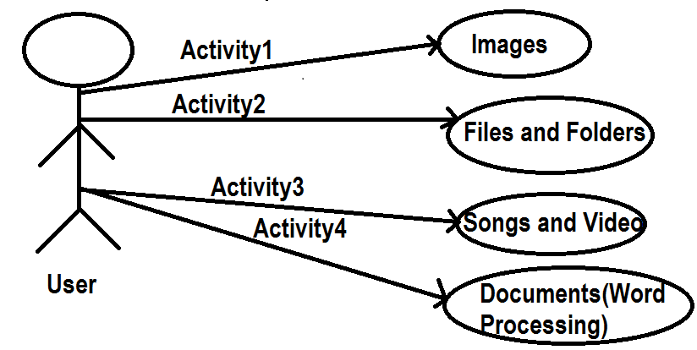

12

**2.2.4 Data Flow Diagram:-**

**0 level DFD (Context Diagram)**

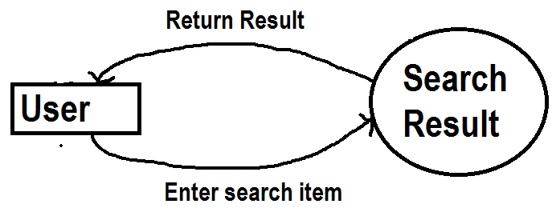

Data flow diagram is used to represent the flow of the data b/w different – 2 processes.

It is also defines the sequence of the flow by which process will be completed.

15

**Data Flow Diagram:-**

**1 level DFD (Intermediate Diagram)**

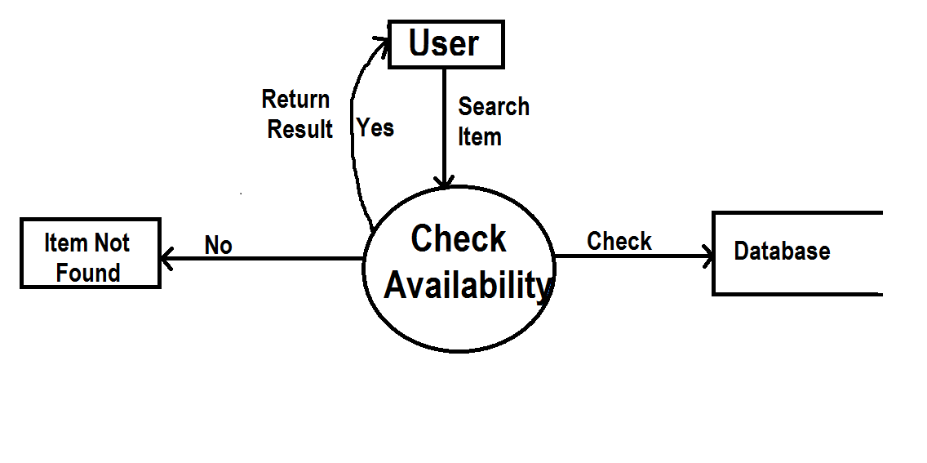

**Some DFD Symbols Meaning**

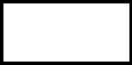 Source or Destination or Data

 Data Flow

16

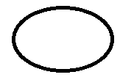 Process that Transforms Data Flow

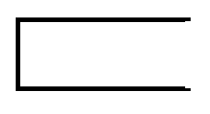 Data Store (can be a card file, a filling cabinet, a database on disk etc.)

17

**CHAPTER-3**

**Logical and Physical**

**Design of System**

18

**3.1 Class Diagrams**

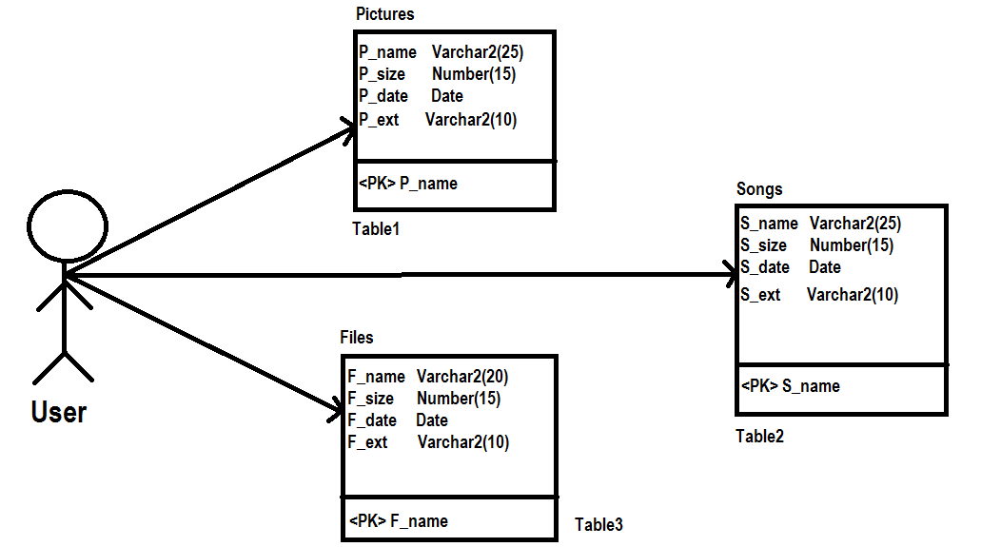

19

**3.2 Layout of the Project:-**

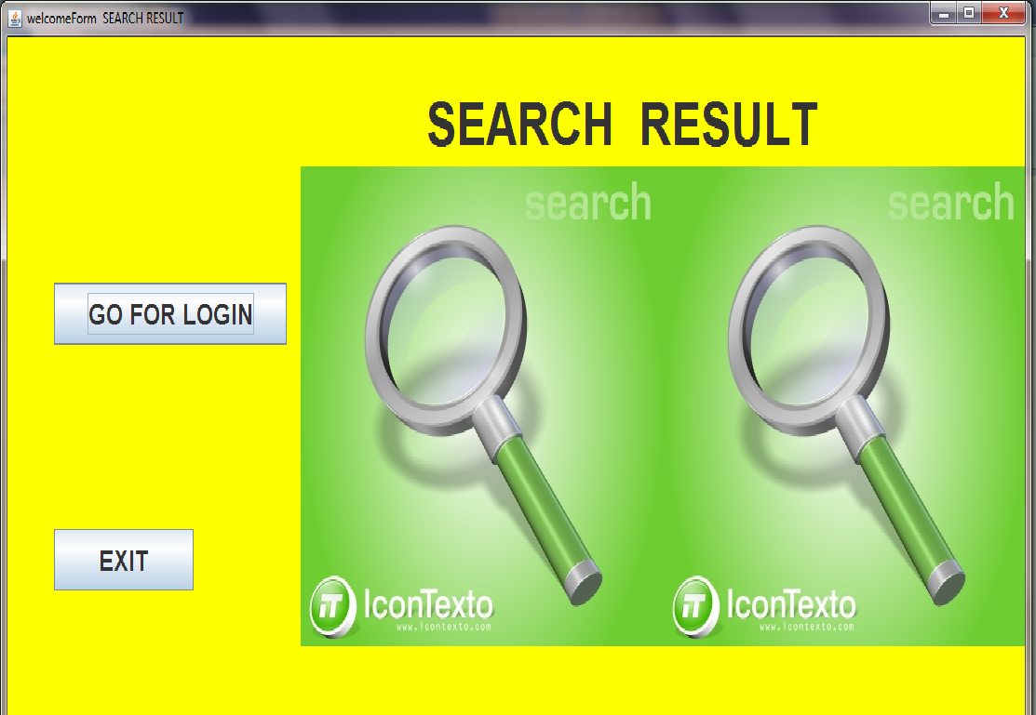

20

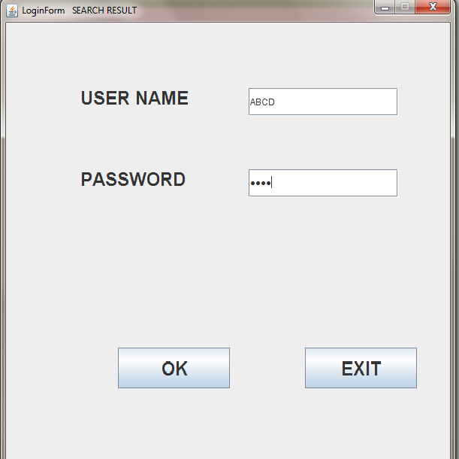

21

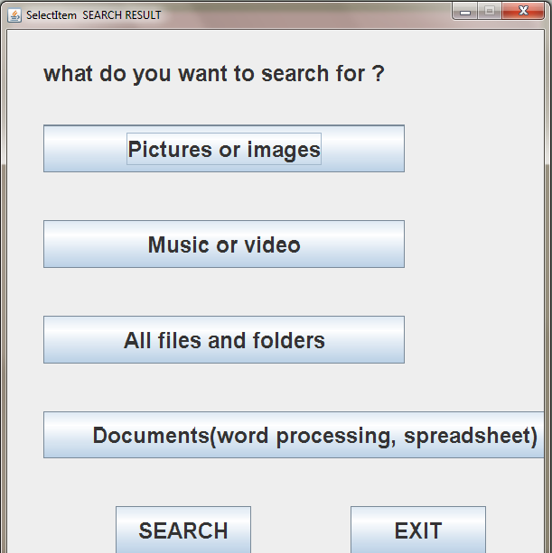

22

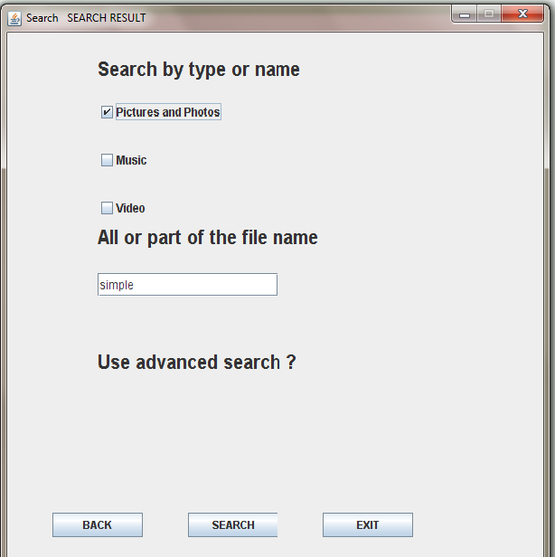

23

**CHAPTER-4**

**System Testing and Implementation**

24

**4.1.1 Testing:-**

Testing is a process to show the correctness of the program. Testing is needed to show completeness, t improve the quality of the software and to provide the maintenance aid. Some testing standards are therefore necessary reduce the testing costs and operation time. Testing software extends throughout the coding phase and it represents the ultimate review of configurations, design and coding. Based on the way the software reacts to these testing, we can decide whether the configuration that has been built is study or not. All components of an application are tested, as the failure to do so many results in a series of bugs after the software is put to use.

**4.1.2Black Box Testing:-**

Black box testing focuses on functional requirements of the software. That is, black box testing enables the software engineer to derive sets of input conditions that will fully exercise all functional requirements for a program. Black box testing is not an alternative to white box testing. Rather it is complementary approach that is likely to uncover a different class of errors than white box methods.

Black box testing attempts to find errors in the following categories

1. Incorrect or missing functions

2. Interface errors

3. Errors in data structure or external data base access

25

4. Performance errors

5. Initialization and termination errors

Unlike white box testing, which is performed early in the testing process? Black box testing tends to be applied during later stages of testing. Because of Black Box Testing

Tests are designed to answer the following questions:

1. How is functional validity tested?

2. What class of input will make good test cases?

3. Is the system particularly sensitive to certain input values?

4. How are the boundaries of a data class isolated?

5. What effect will specific combinations of data have on system operation?

**White Box Testing:-**

White box testing knowing the internal working of a system tests can be conducted to ensure that internal operations are performed according to specifications and all internal components have been adequately exercised.

1. Using White Box Testing method the tests cases that can derive are:

2. All independent paths with in a module have been exercised at least once.

3. Exercised all logical decisions their true or false side.

4. Execute all loops at their boundaries and within their operational bounds.

5. Exercise internal data structures to ensure their validity.

26

**4.1.4 Test Plan:-**

The importance of software testing and its implications cannot be over emphasized. Software testing is a critical element of software quality assurance and represents the ultimate review of the specifications, design and coding.

**4.1.5 Test Case Design:-**

The testing phases involve the testing of the developed system using various test data. Preparation of the test data plays a vital role in the system testing. After preparing the test data the system under study was tested using those test data.

While testing the system, errors were found and corrected by using the following testing steps and corrections are also noted for future use. Thus, a series of testing is performed for the proposed system, before the system was ready for the implementation.

**4.2.1 Unit Testing**

Unit Testing verifies the smallest modules of the software designed. Using this testing the entire module can be debugged very easily. The relative complexity of test and the errors detected as a result its limited by the constrained scrap established for unit testing.

The unit test is always white box oriented and the step can conduct in parallel for multiple modules.

27

Unit testing is considered an adjunct to the coding step. After source code has been developed and verified for the syntax connection, unit test case designed starts.

**4.2.2 Integration Testing**

Integration testing focuses on design and construction of software architecture. For Ex:- We followed a systematic technique for constructing the program structure that is “putting them together” interfacing at the same time conducting tests to uncover errors . We took unit tested components and build a program that has been dictated by design.

**4.2.3 Validation Testing**

It is achieved through a series of black box tests. An important element validation process is configuration review. It is intended for all the elements are properly configured and cataloged. It is also called AUDIT.

**4.2.4 System Testing**

The last high order testing step falls outside the boundary of software engineering and into tile broader context of computer system engineering. Software, once validate, must be combined with other system elements (e.g., hardware, people and database).

System testing verifies that all elements mesh properly and that overall system function/performance is achieved.

28

**CHAPTER-5**

**Conclusion/Bibliography/Appendix**

29

**5.1 Conclusion**

This project will use to access or extract an information about persons related, images, songs, files and folders and documents (word processing, spread sheet etc) from the database of the system. It is easy for them to find any item related to specific subject by searching the desired topic in our text field. It is payable application and offline which reduces user time for search an items.

Information is one of the effective logic-based that provide an alternative way for the user and business environment will be increases.

30

**5.2 Future Scope**

At least it is obvious that there is a reason for the improvement in any software package however good and efficient it may be. But the important thing is that the system should be flexible enough for accepting modifications in future. This system has been designed in such a way that any changes can be incorporated in the system without affecting the actual design of the system.

This Business world is dynamic in nature and thus it is obvious that as time changes and business expands new requirements will take birth and hence enhancements are required for which this system is very flexible that may be an addition of a module or some forms.

31

**5.3. Bibliography**

**REFERENCES:**

**Books:**

The Complete Reference of java

Black Book

**Web Resources:**

[**www.codeproject.com**](http://www.codeproject.com)

[**www.planet_source_code.com**](http://www.planet_source_code.com)

32

**2.2.3 Data Dictionary**

A data dictionary lists all the data items appearing in a DFD i.e. a data dictionary lists all data flows and the contents of all data stores appearing the DFD.

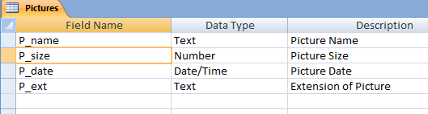

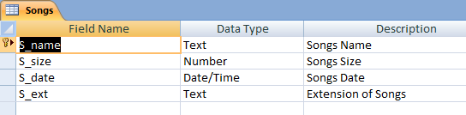

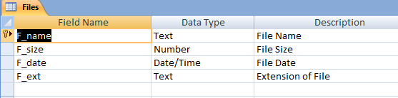

13

**2.2.4 Entity Relationship Diagram**

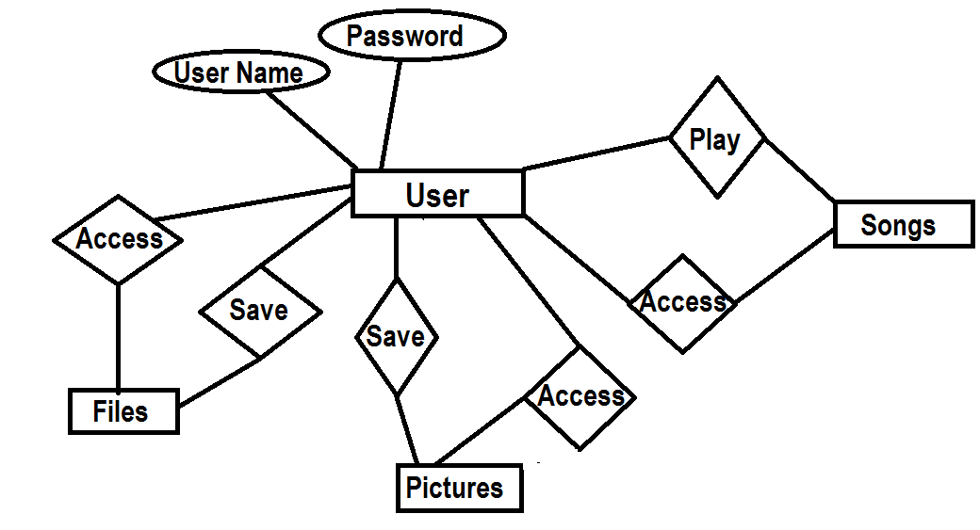

14